Q2 use cdac_krishna;

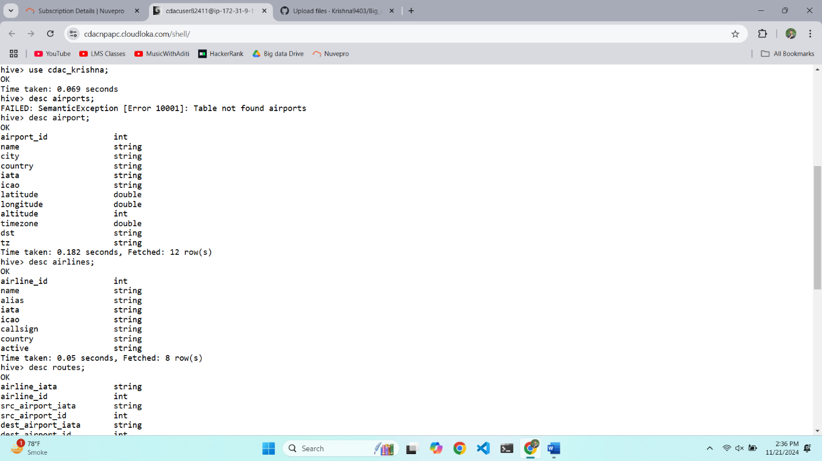

Creating table - create table src_air(airport_id int , name string, src_airport_is int, dest_airport_iata string, dest_airport_id int, codeshare string, stops int, equipment strin

g) partitioned by (src_airport_iata string) row format delimited fields terminated by ',' stored as textfile;

Inserting data - insert overwrite table src_air partition (src_airport_iata) select routes.airline_iata , routes.airline_id, routes.src_airport_id, routes.dest_airport_iata, route

s.dest_airport_id, routes.codeshare, routes.stops, routes.equipment, routes.src_airport_iata from routes distribute by routes.src_airport_iata;

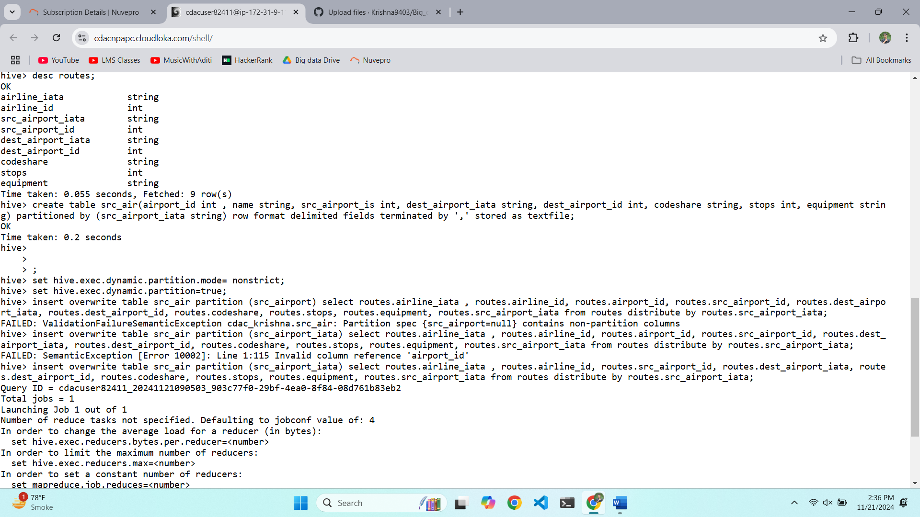

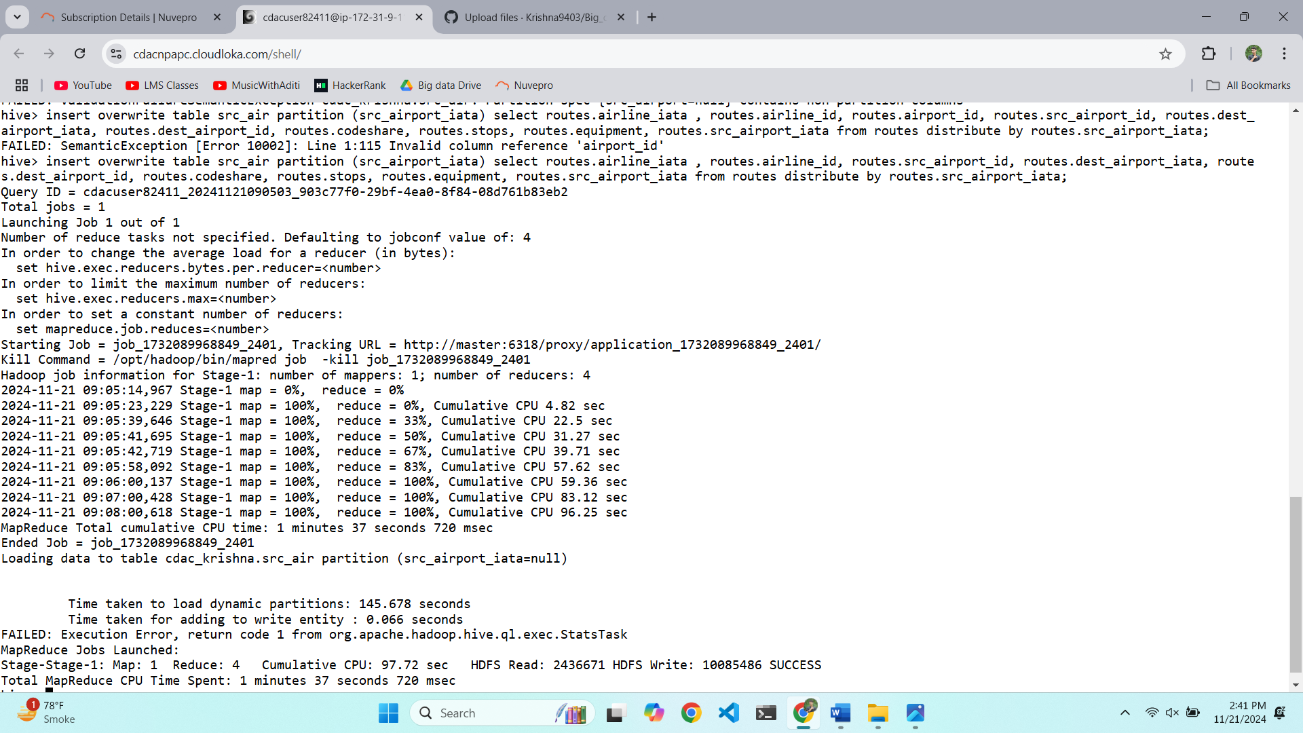

Partition created -

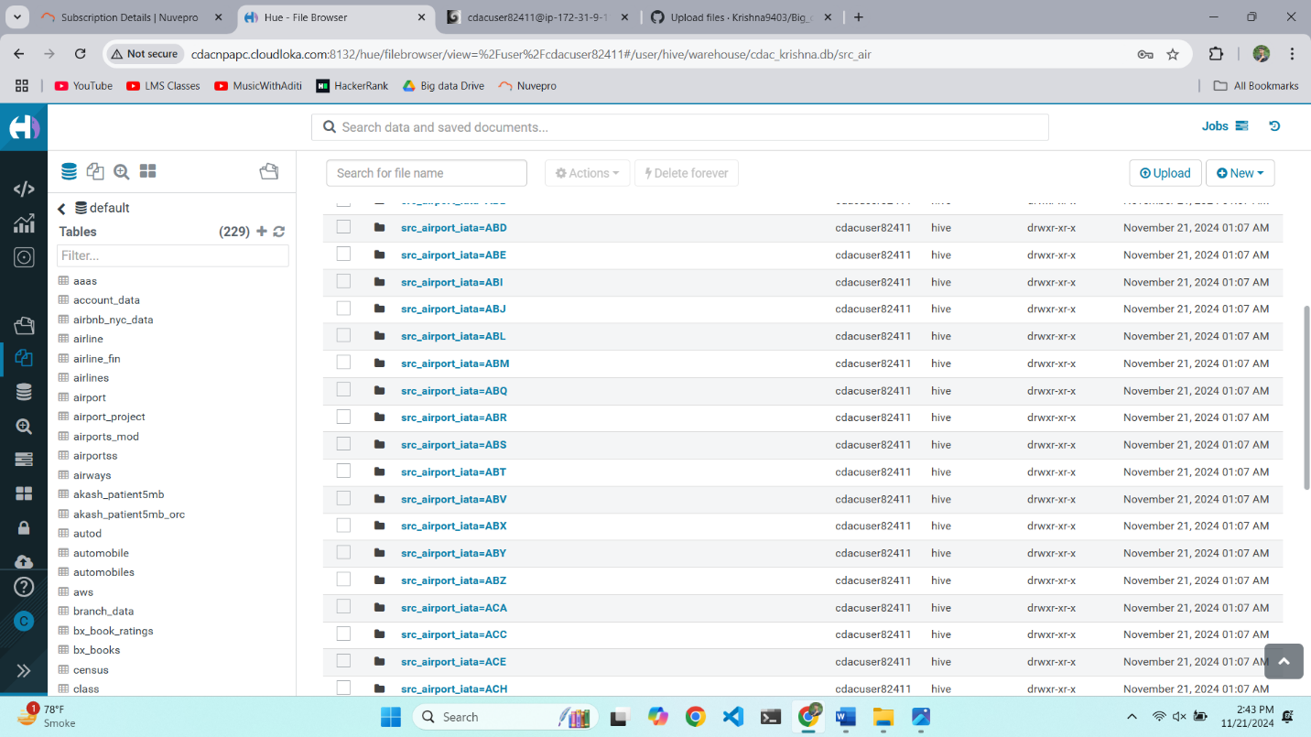

set hive.vectorized.execution.reduce.enabled=false;

set hive.vectorized.execution.enabled=false;

set hive.enforce.bucketing=true;

4.

Show partitions src_air;

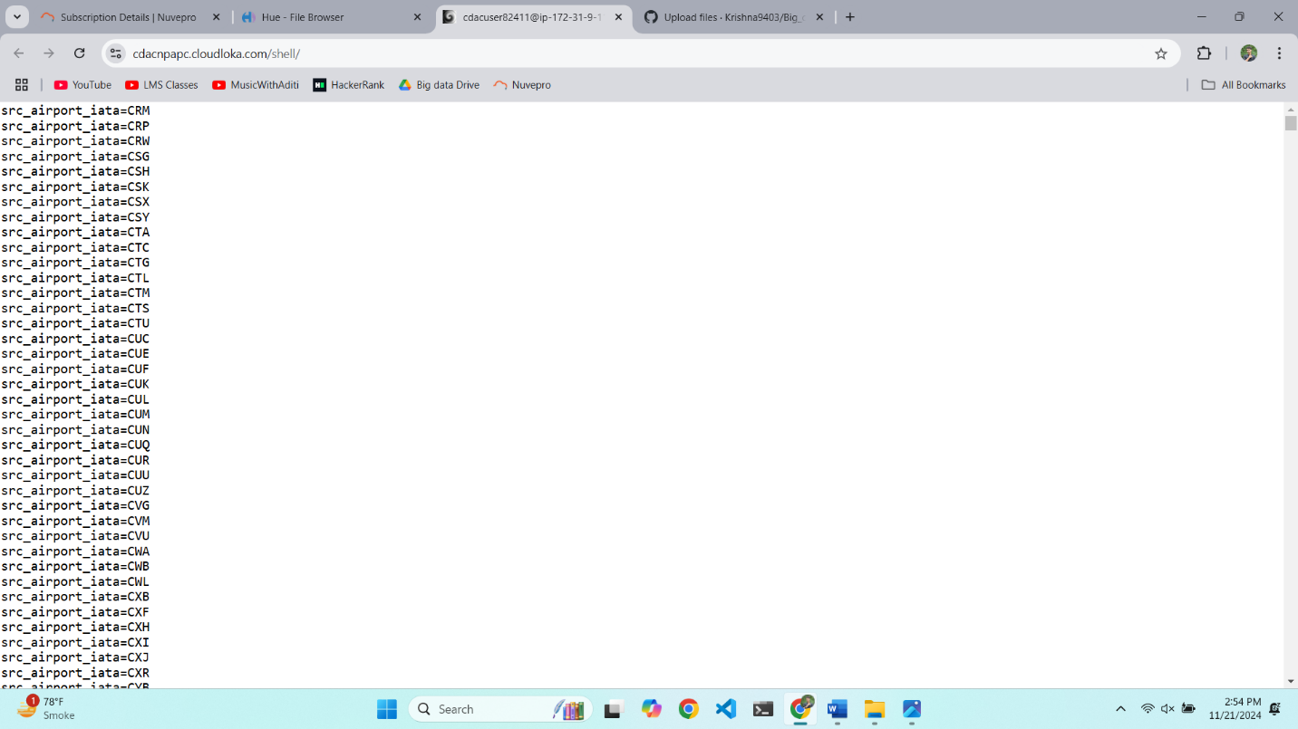

Spark

Q1

1. >>> df.groupBy("Quarter").sum("booked_seats").show()

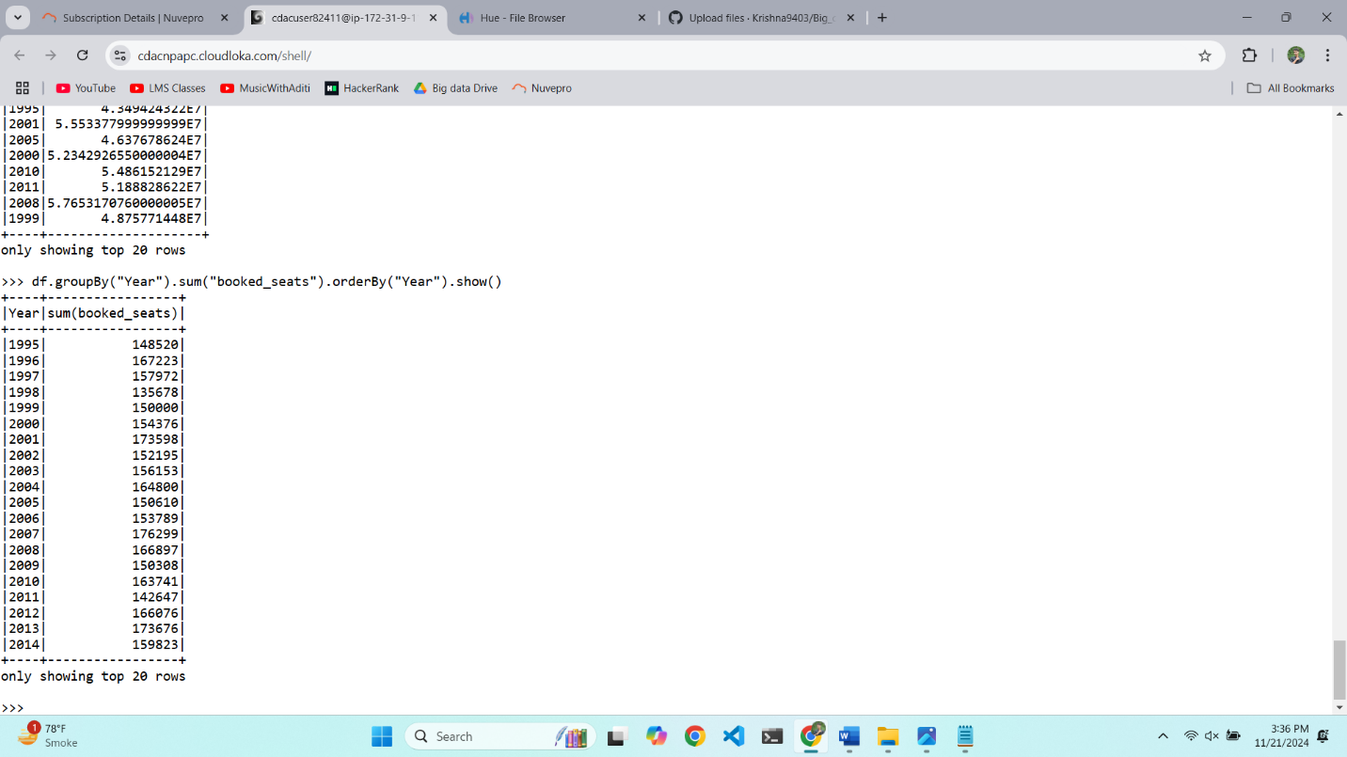

Q2.

1.

Max of Average revenue per seat

>>> df.orderBy("Avg_rev_per_seat",ascending=False).limit(1).show()

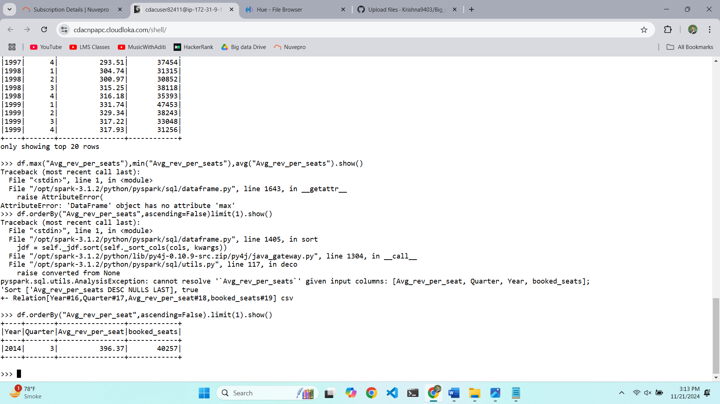

Max of Average revenue per seat

>>> df.orderBy("Avg_rev_per_seat").limit(1).show()

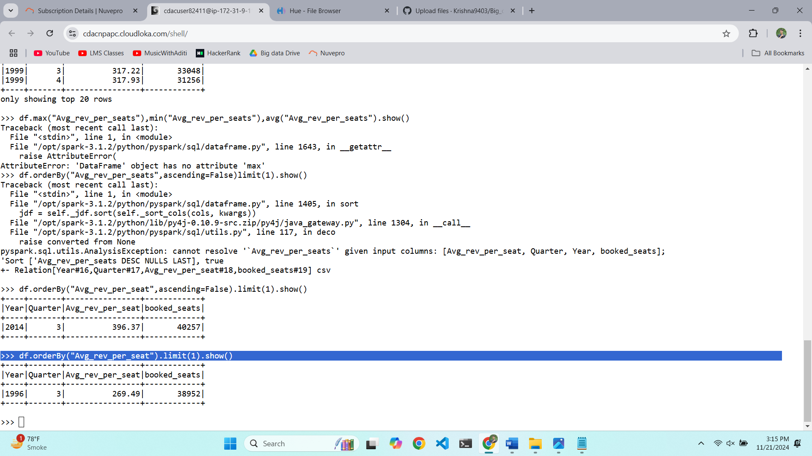

Max of Average revenue per seat

>>> df.agg(avg("Avg_rev_per_seat")).show()

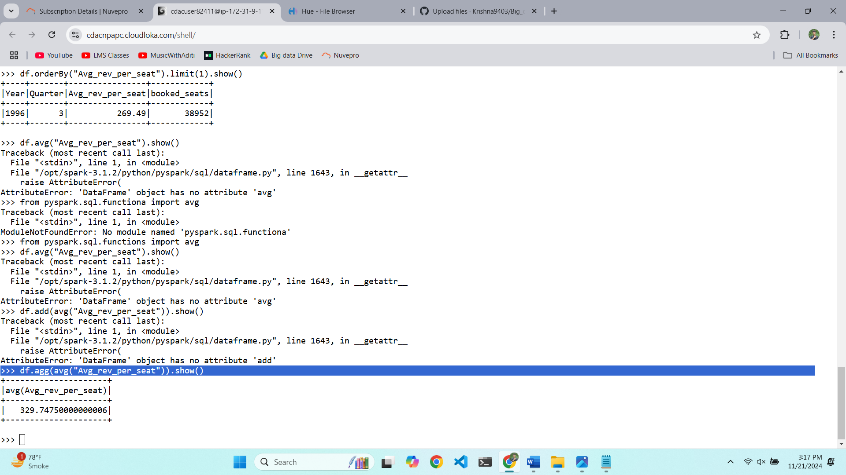

3.

>>> df.groupBy("Quarter").sum("booked_seats").show()

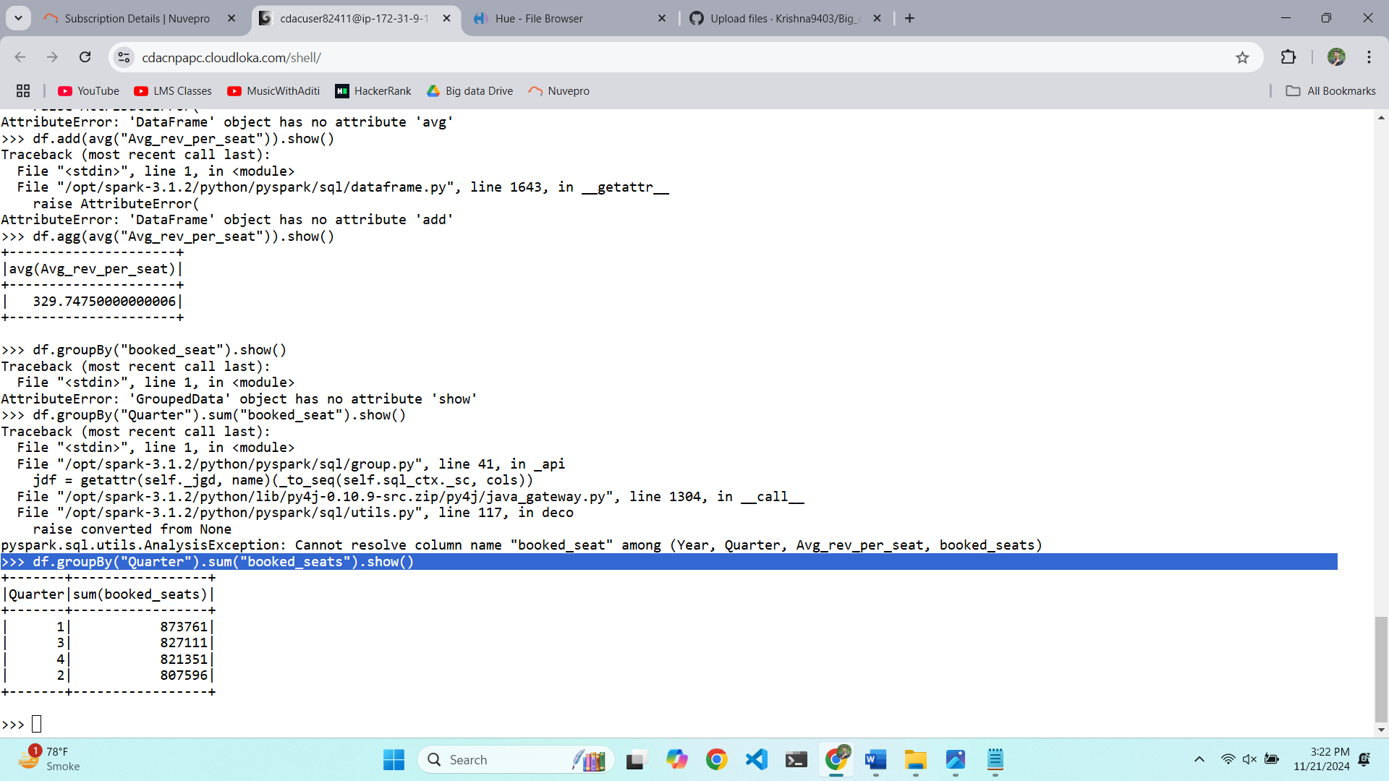

4.

>>> df.groupBy("Year").sum("booked_seats").orderBy("Year").show()

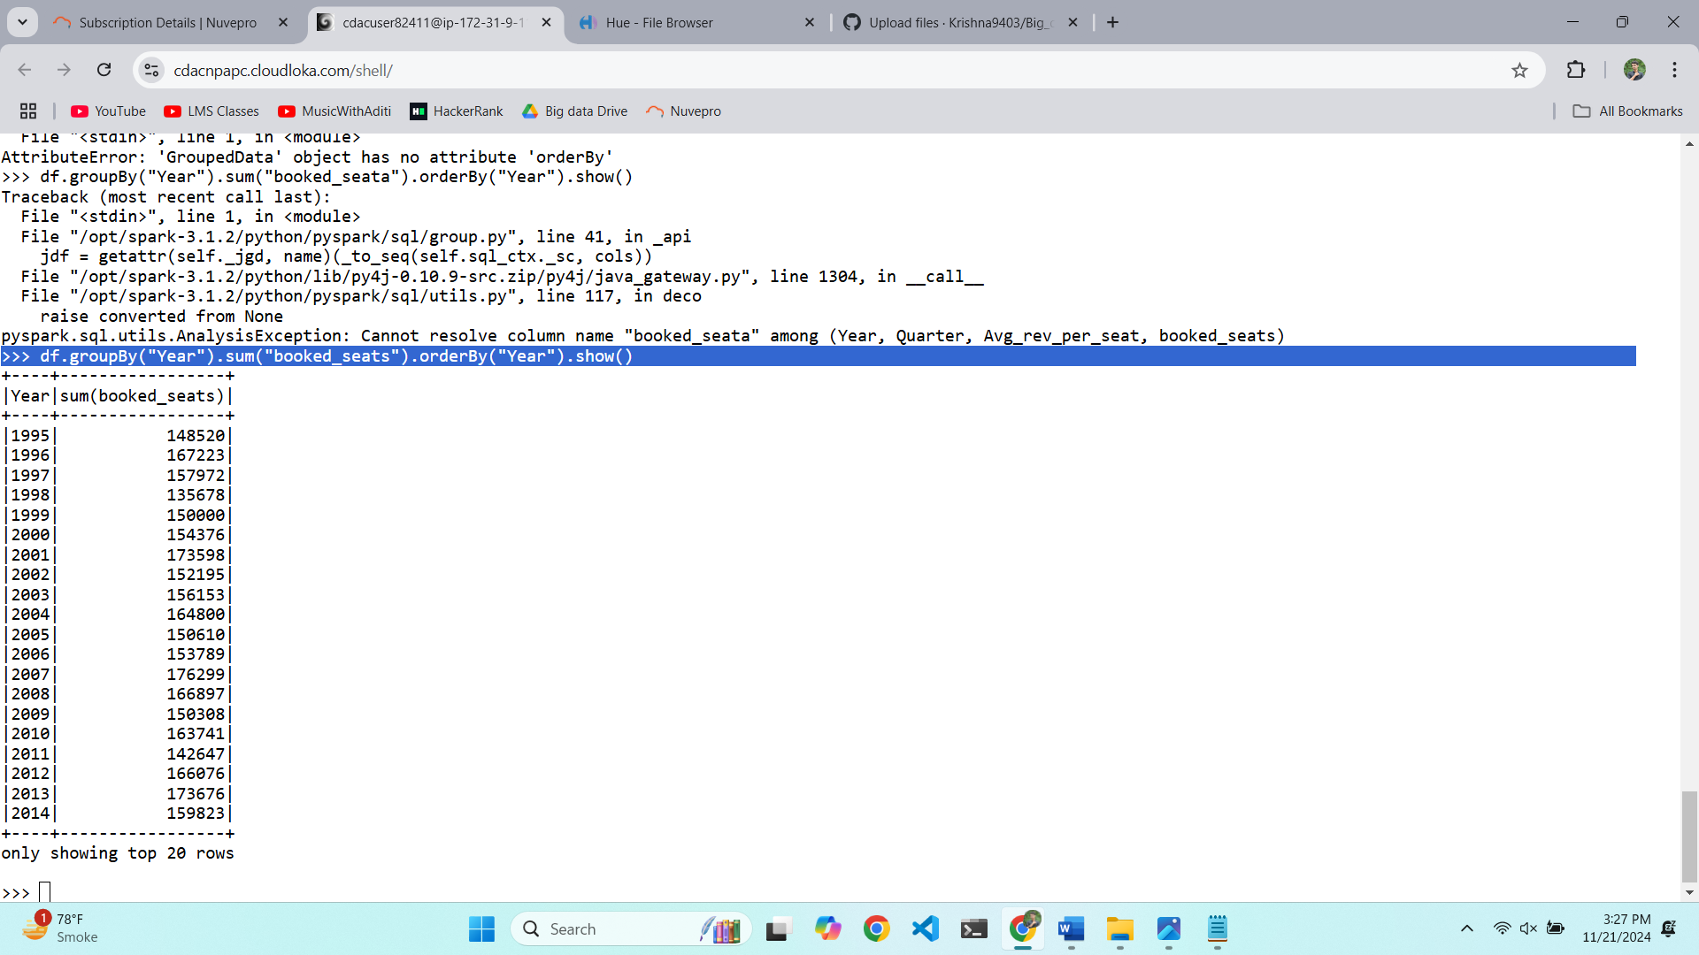

5. >>> df.withColumn("Revenue",col("Avg_rev_per_seat")*col("booked_seats")).groupBy("Year").sum("Revenue").show()

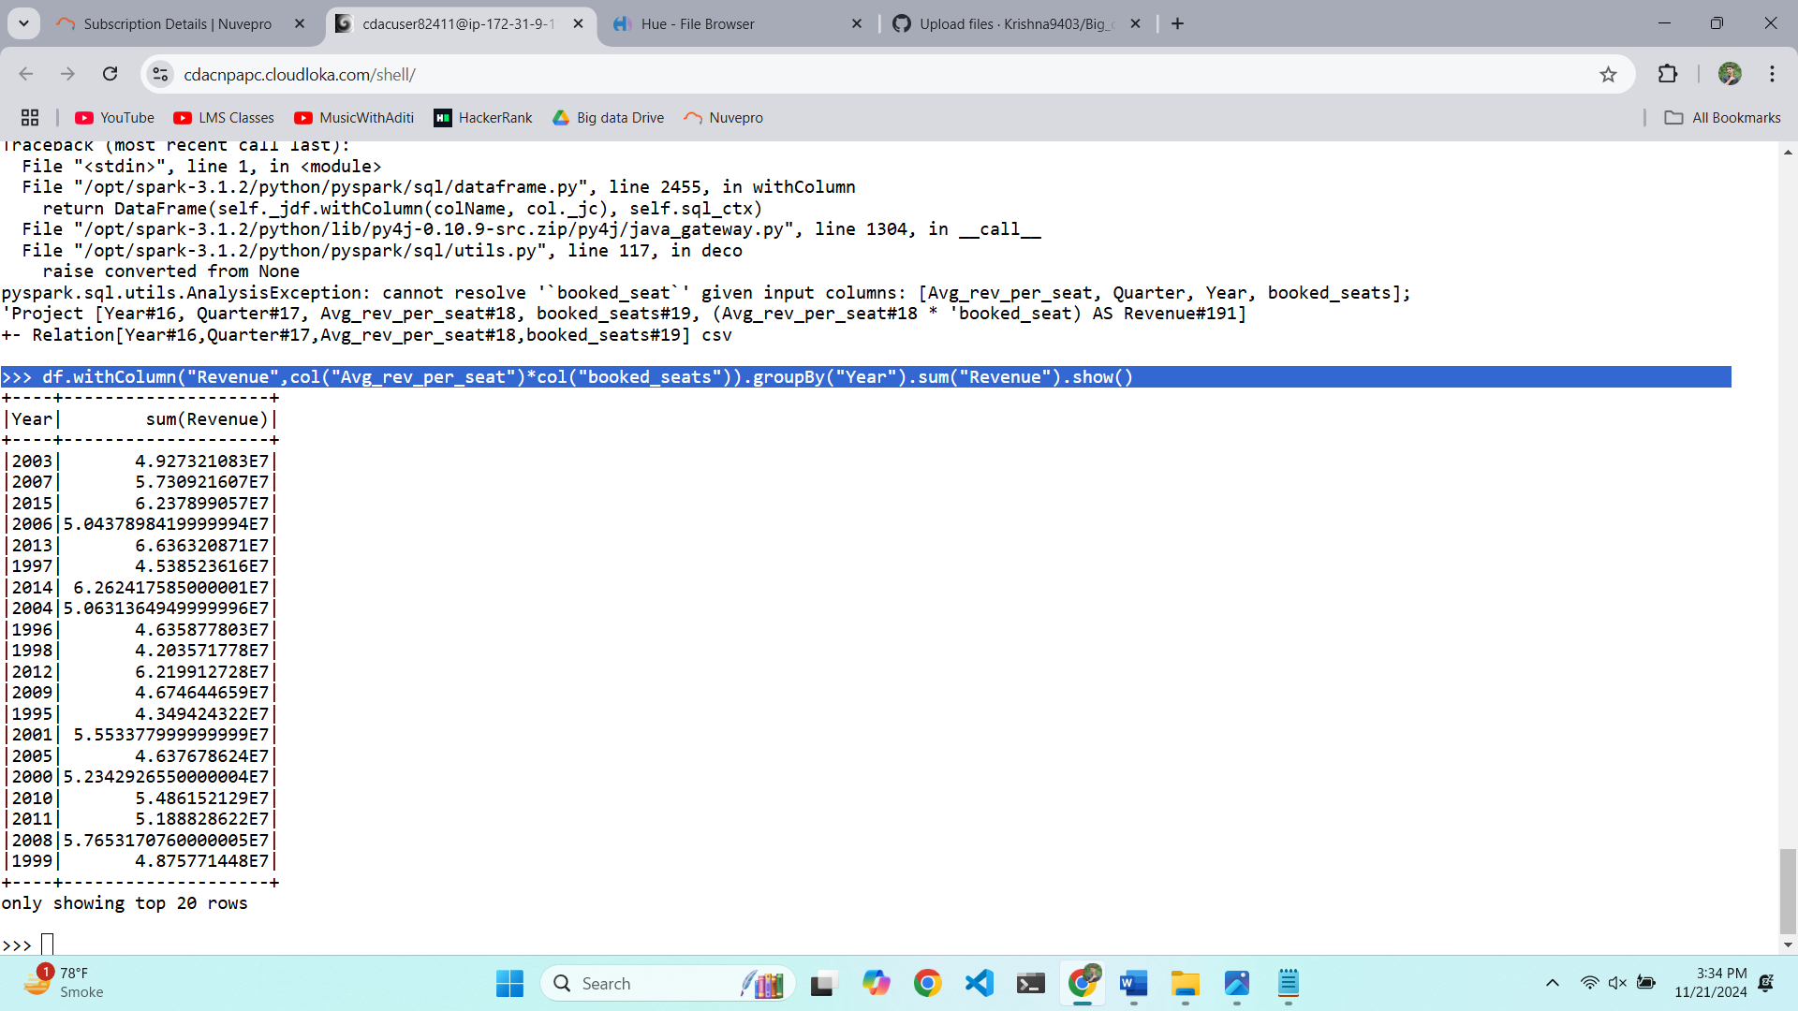

SELECT equipment_id, COUNT(DISTINCT route_id) AS route_count FROM equipment_usage GROUP BY equipment_id ORDER BY route_count DESC